**CSW201**

**DIGITAL PHOTOGRAPHY AND IMAGING**

**ASSIGNMENT 2**

**“Life of Fisherman in Coastal Kedonganan”**

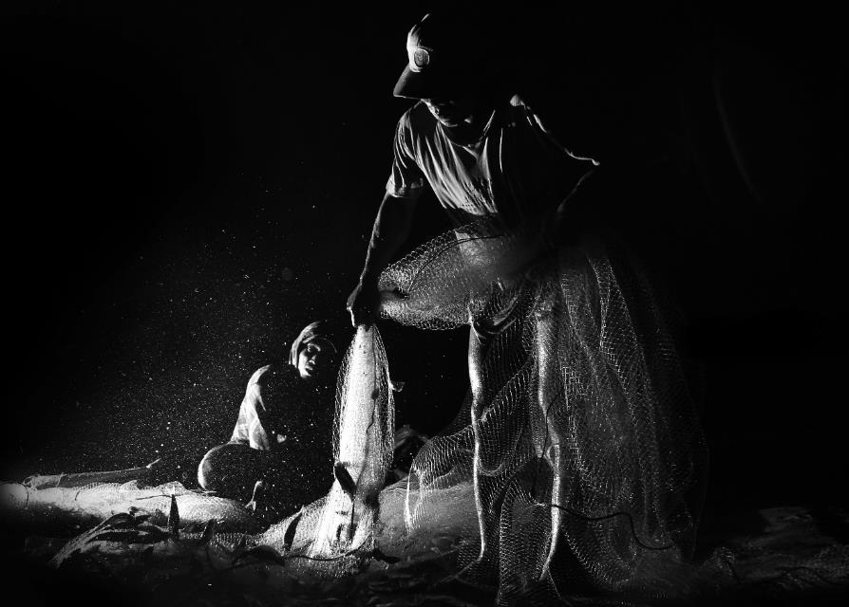

**I Wayan Wiguna Adinata**

**E1300179**

**Abstract**

Kedonganan is a district at southern of Bali Island. Kedonganan is a place that very famous because its crowded beach. Lot of activities is happening in here. Various human activities can be found here. Starting with the beautiful and luxurious restaurant lined in the seaside that can be spoil the tongue in the afternoon, until the frenzied trading that occurred at the only one fish market in the south of Bali's

Not far from the hectic activity in the restaurant appetizing and bustle of commerce in the fish market, there is another side Kedonganan Beach there is the activity of the fishermen are not so much attention of people who visited this coast. A small harbor is filled with fishermen that return from sea and bring their catch, it is very interesting moment that can be a story in the form of documentary photography.

This is the underlying raised this theme for assignment 2 CSW201-Digital Photography and Imaging. The story of the fishermen in Kedonganan from them to land after fishing all night, unload their catches up until late of the night. Not only were the facilities at Kedonganan Beach and children activities of the fishermen was recorded and retold in this second assignment.

**1st Photo**

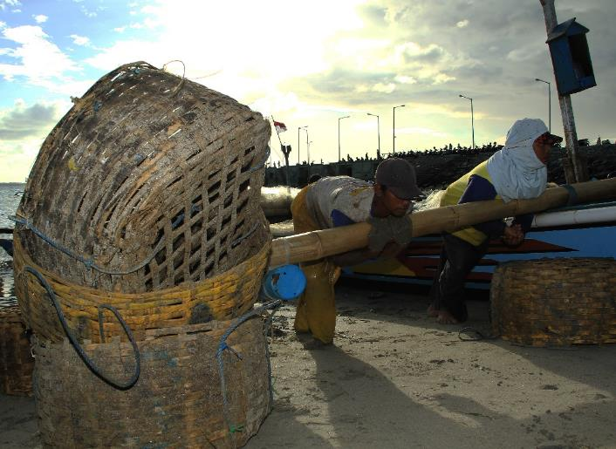**“Arrived in Coastal”**

**Description:**

This photo was taken after the fisherman in the cost in returned to the land after sailing all night. In this photo there are two men pushing the boat from the ocean to the coast, they are look tired and very sweat. In this photo, the point of interest is focus on the wooden bucket beside of two fishermen. The daylight was very strong and make good effect on the fisherman, there is shadows.

|  |  |
| --- | --- |
| **Strength** | **Weakness** |
| Combination between direct lighting that produce shadow on fisherman and focus on bucket make good combination | Direct lighting was too strong, then the photographer should use flash to prevent silhouette on bucket |

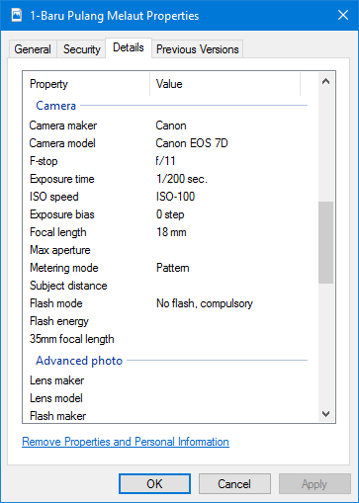

**Technique Used:**

Rules of Third

**Editing Information:**

Crop dimension from 5184x3546 to 4740x3556, Brightness -102, Contrast +13.

**2nd Photo**

**“Unload the Fish”**

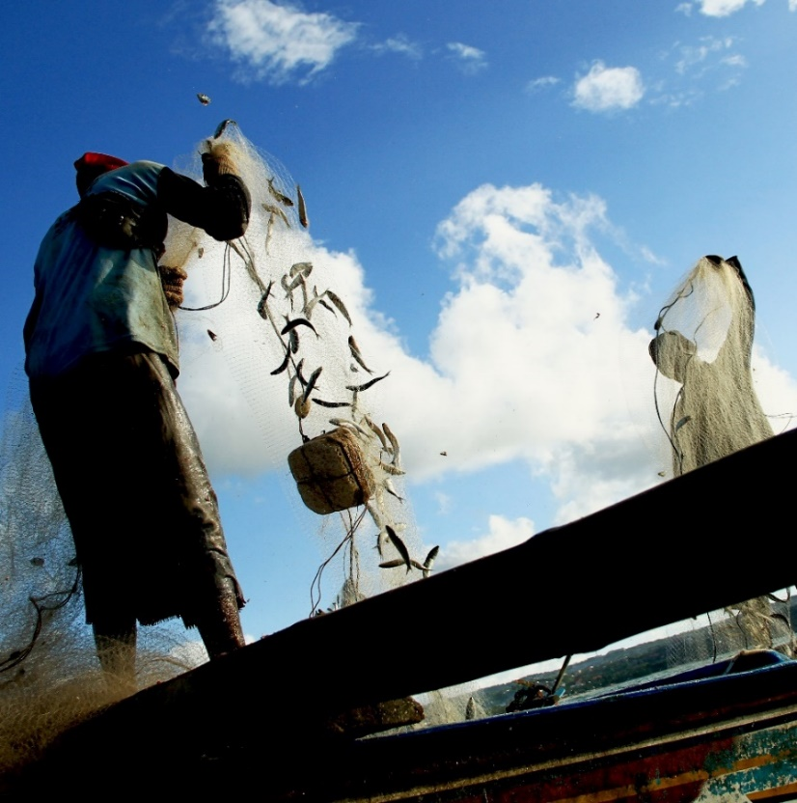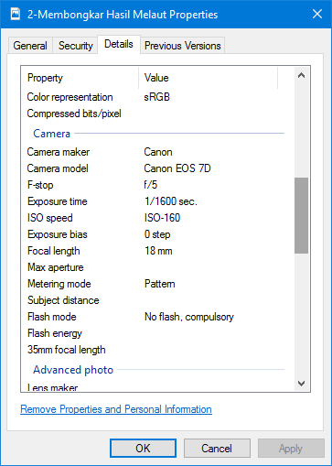

**Description:**

In this photo is taken while the fisherman and his crew started to unload the fishes from their boat. There are many of sardine fishes fulfilling their boat, and they were collected by the fisherman when they were hang in the nets. This photo was taken with frog eye make different perspective to the viewer and good combination between high contrast of the background and the object make the object is had strong appearance.

|  |  |
| --- | --- |
| **Strength** | **Weakness** |
| Different angle make the photo has unique combination and perspective. | The angle of photo is too wide and brightness too high make photo need crop and edit. |

**Photography Technique:**

Point of View – Frog Eye

**Editing Information:**

Crop, Exposure -0.28, Offset -0.0207, Gamma Correction +0.81, Brightness +56, Contrast +8.

**3rd Photo**

**“Fishes in Nets”**

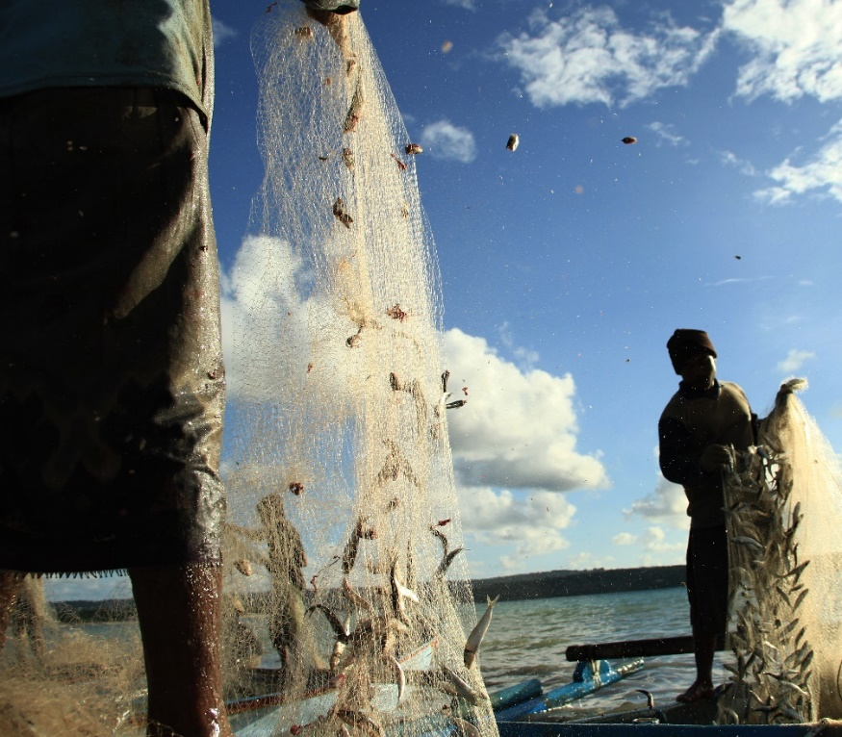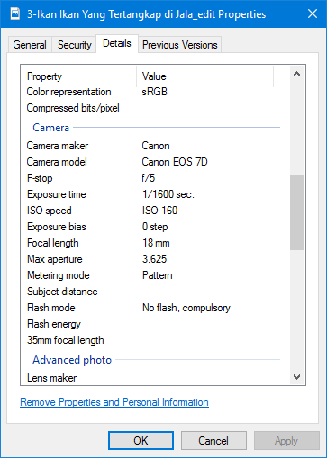

**Description:**

This photo is same part of second photo but used different technique. In this photo the point of interest is the left net with lot of sardines hanging. The sunlight make the object has unique balance color and strong contrast with the background. This photo also tells the viewer about how work of the fisherman really is.

|  |  |
| --- | --- |
| **Strength** | **Weakness** |
| Good contrast between object and background | Strong direct lighting makes this photo need editing |

**Photographic Technique:**

Rules of Third

**Editing Information:**

Crop, Brightness -35, Contrast +45.

**4th Photo**

**“Fisherman and His Fish”**

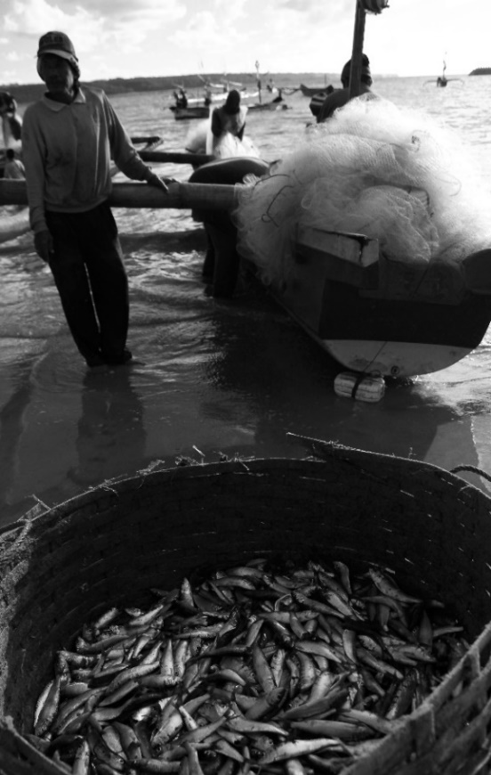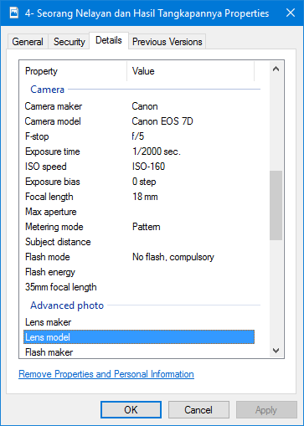

**Descriptions:**

In this photo the point of interest is wooden bucket that full with fish and with the background of a fisherman, the background is light blurry because focus of the camera is in the wooden bucket and reason of this photo taken with portrait because I want to show about the result of the harwork from the fisherman.

|  |  |
| --- | --- |
| **Strength** | **Weakness** |
| Monochrome effect make the photo more dramatic. | Limited lighting in this angle make the object is blur and doesn’t get enough lighting |

**Photographic Technique:**

Portrait

**Editing Information:**

Crop, Brightness +31, Constract -13, B/W effect

**5th Photo**

**“Helping His Parents”**

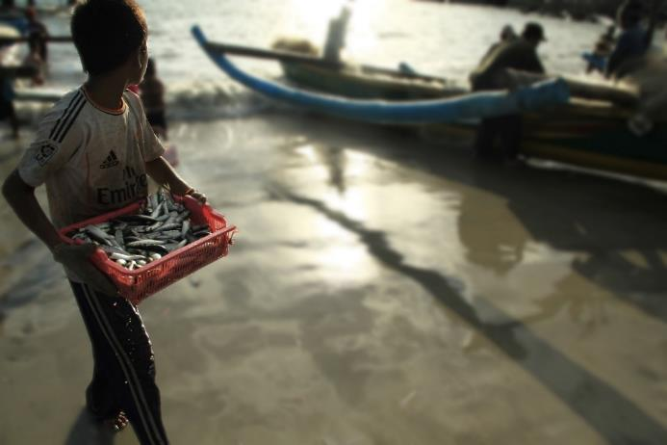**Description:**

This photo is taken while the young man carried a plastic bucket with full of fishes. This young man is a son of one of the fisherman that still unload their fishes from the boat. Based of his apperance, this young man is very diligent helping his parents, he not shy helping his parent even under the heat of the sunlight. That is a good attitude as good son.

|  |  |
| --- | --- |
| **Strength** | **Weakness** |
| Good angle while taking the photo make unique perspective | Limited lighting in this angle make the object is blur and doesn’t get enough lighting |

**Photographic Technique:**

Rules of Third

**Editing Information:**

Crop, Brightness +6, Smart Filter, Gaussian Blur +8.0

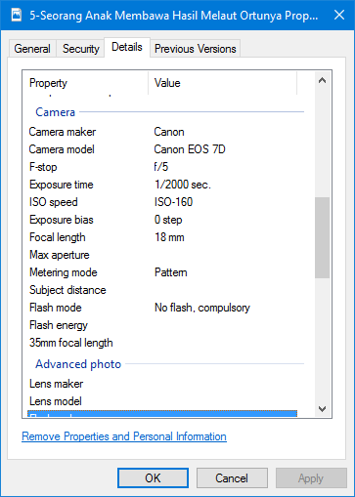

**6th Photo**

**“We Are Strong Under The Sun”**

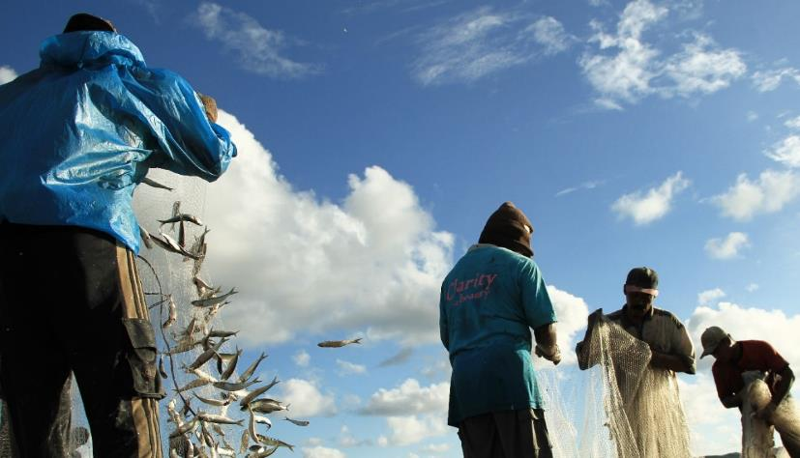

**Description:**

The daylight is very strong and the skin feels like burns but those aren’t a big problem “the fantastic four”, four strong fishermen that still focus to clean their nets from the fishes that still stick in it. Example of high integrity of work and can be good sample for us. Uniquely while photo was taken, they are stand with uncommon combination.

|  |  |
| --- | --- |
| **Strength** | **Weakness** |
| Good angle while taking the photo make unique perspective | Strong sunlight and angle make the fisherman as the object can’t get enough lighting |

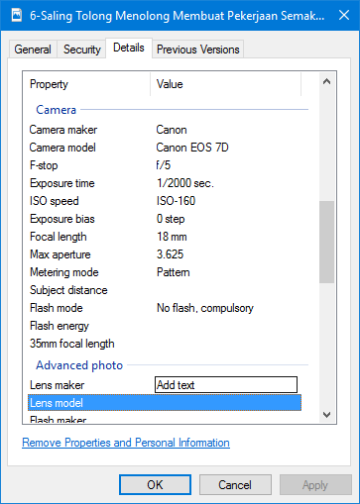

**Photographic Technique:**

Diagonal Composition

**Editing Information:**

Crop, Brightness +9

**7th Photo**

**“Soulmates in The Middle of the Sea**”

**Description:**

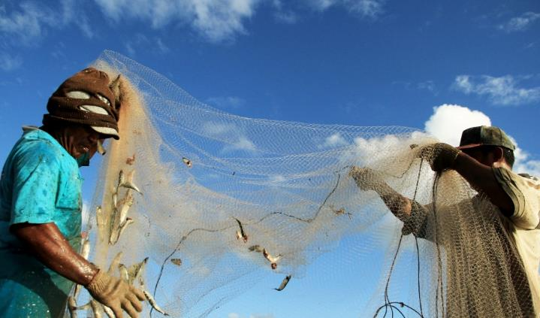These two men is two soulmates in the middle of the sea. These two men had work together in one boat for couple of years. They are helping each other to make their work more easily. In this photo they are cleaning the nets from the fishes that still stick in. Two men that work together for make money for their family.

|  |  |
| --- | --- |
| **Strength** | **Weakness** |
| Good angle while taking the photo make objects is dominated | Low intensity on the right object make the object not balance |

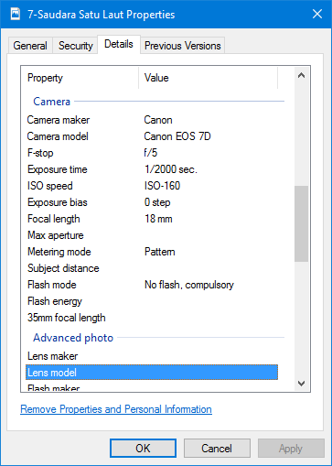

**Photographic Technique:**

Point of View – Frog Eye

**Editing Information:**

Crop, Color Levels RGB, Brightness +18, Contrast +29

**8th Photo**

**“So Proud”**

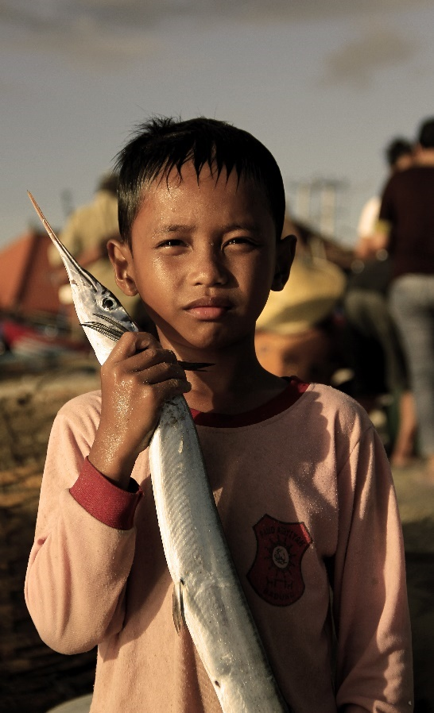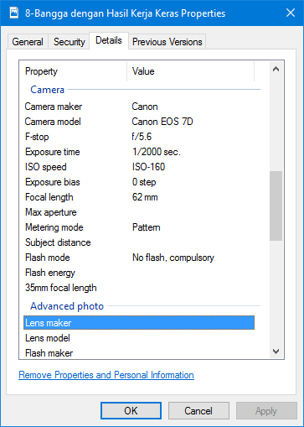

**Description:**

A fisherman’s child look so proud to tell anyone about his father catch. The fish is an average size and look so fresh and juicy. With sepia filters, make the photo looks better.

|  |  |
| --- | --- |
| **Strength** | **Weakness** |
| Direct lighting from the sunlight make good side light effect on the object | Direct lighting is not covering the object perfectly |

**Photographic Technique:**

Depth of Field

**Editing Information:**

Photo Filter: Sepia, Color Level RGB, Contrast +15, Brightness +4

**9th Photo**

**“Sun is Part of Us”**

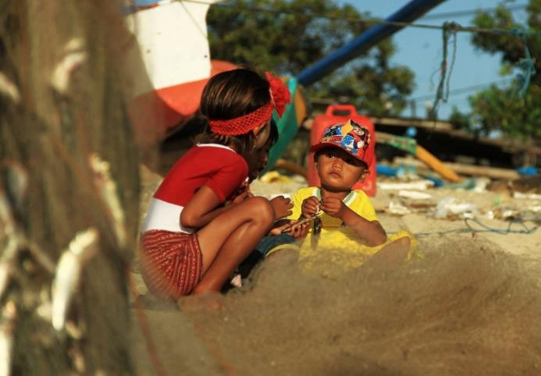**Description:**

The photo showing of couple of children consist of 3 children, two boys and one girl. They are talk each other share their experience and story. Even under strong sunlight, they still focus on their conversation.

Not far from them, there are couple of boats and nets.

|  |  |
| --- | --- |
| **Strength** | **Weakness** |
| Good combination between partial framing from net and depth of field of the object | Framing in this photo only partial and little bit odd |

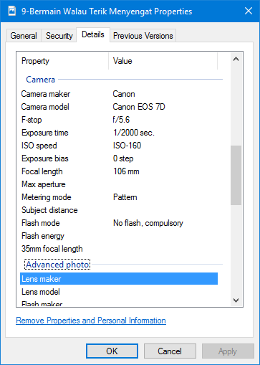

**Photographic Technique:**

Framing

**Editing Information:**

Crop, Contrast +48

**10th Photo**

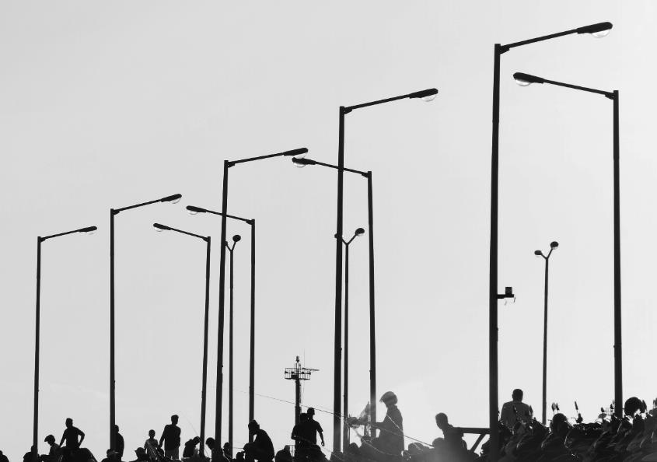**“Light Sources When the Night Come”**

**Description:**  
A row of street light stands near the coast. They are look so gentle and sturdy, not far from them there are lot of people fishing in the dock and couple of motorcycle parking beside crowded of people.

|  |  |
| --- | --- |
| **Strength** | **Weakness** |
| Strong composition between object position and contrast background | Silhouette effect of the object not covering whole object completely |

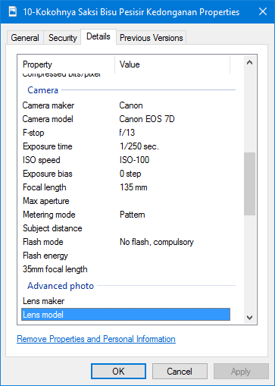

**Photographic Technique:**

Repetition

**Editing Information:**

Crop, B/W, Brightness -24, Contrast +31

**11th Photo**

**“When the Dawn Come”**

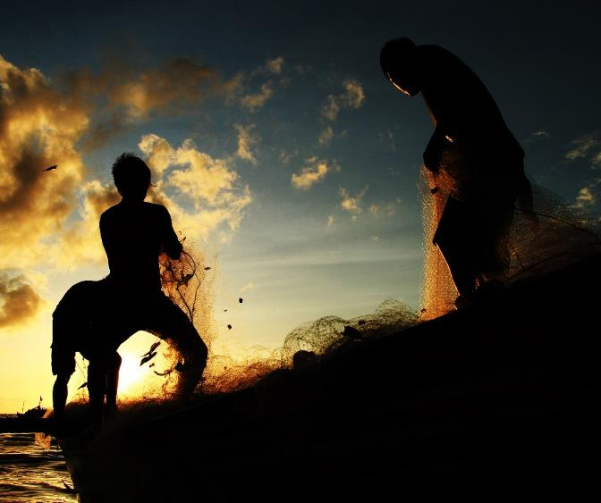**Description:**

Couple of fisherman still unload the fish even the day getting dark. In this photo, three young fishermen still focus to finish them work. In the west horizon, the sun is going to set and day will change to then night day, the light of sun made good effect to the fisherman.

|  |  |
| --- | --- |
| **Strength** | **Weakness** |
| Strong composition between object position and contrast background also proper lighting | Some people may be confuse in the first sight to this photo |

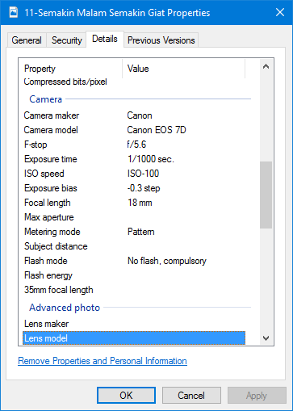

**Photographic Technique:**

Repetition

**Editing Information:**

Crop, B/W, Brightness -24, Contrast +31

**12th Photo**

**“The Hanging Nets”**

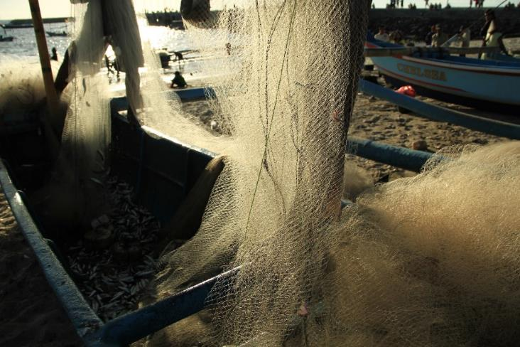

**Description:**

The nets is hanging on the boat after they were cleaned by the fisherman. This is the main equipment of the fisherman to catch the fish. So they need to take care carefully and need cleaning regularly.

|  |  |
| --- | --- |
| **Strength** | **Weakness** |
| Strong composition between object position and contrast background also proper lighting | Some people may be confuse in the first sight to this photo |

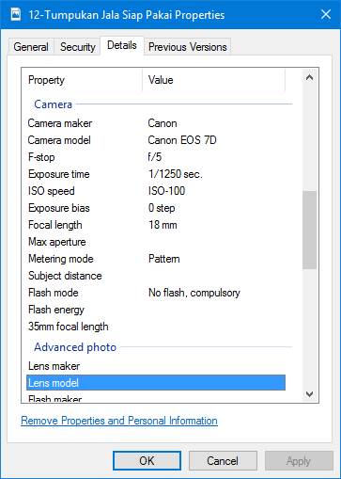

**Photographic Technique:**

Dominant Eye

**Editing Information:**

None

**13th Photo**

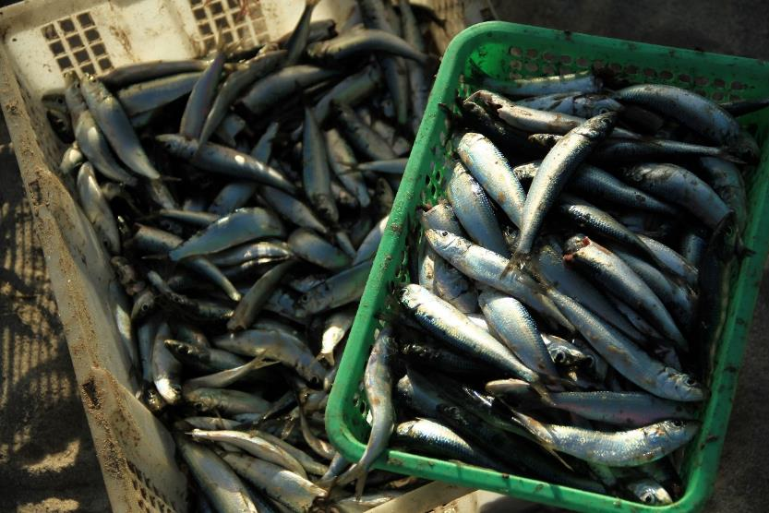**“Fresh in the Bucket”**

**Description:**

This is the close up photo of the sardines. They were looked very fresh and ready to sell to the market near the coast. Fishes on this photo get enough lighting especially in the green square bucket and make good effect to the fishes. Looks shine and juicy.

|  |  |
| --- | --- |
| **Strength** | **Weakness** |
| Direct lighting make good effect to the fishes | Lighting dominant to right object and left object doesn’t get enough lighting |

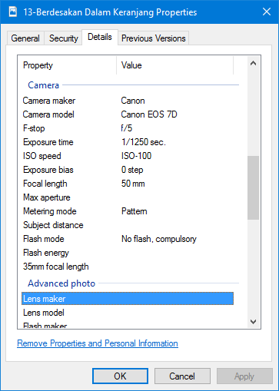

**Photographic Technique:**

Pattern, Rules of Third

**Editing Information:**

None

**14th Photo**

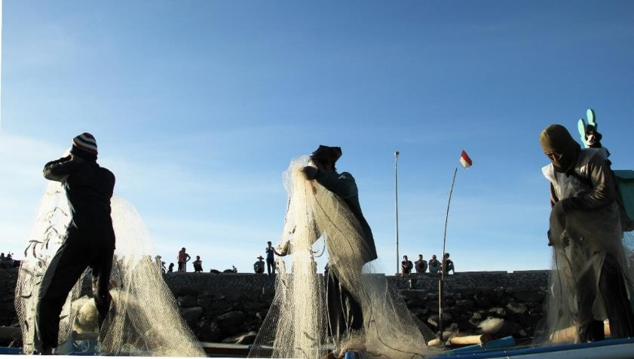**“United We Strong”**

**Description:**

Three fisherman stand on unique position and they focus on cleaning the nets. Near of them, there are some people that watching them did their work.

|  |  |
| --- | --- |
| **Strength** | **Weakness** |
| Strong composition between object position and contrast background | The silhouette is not appear perfectly |

**Photographic Technique:**

Horizontal Composition

**Editing Information:**

Crop, Color Level RGB, Brightness +33

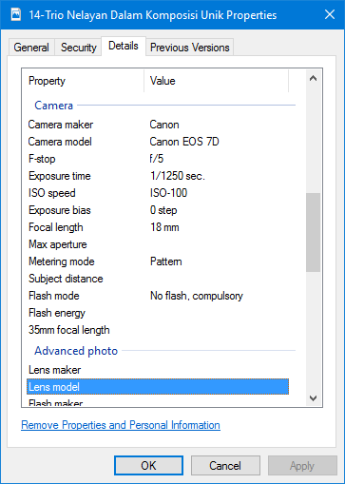

**15th Photo**

**“We Believe We Can Fly”**

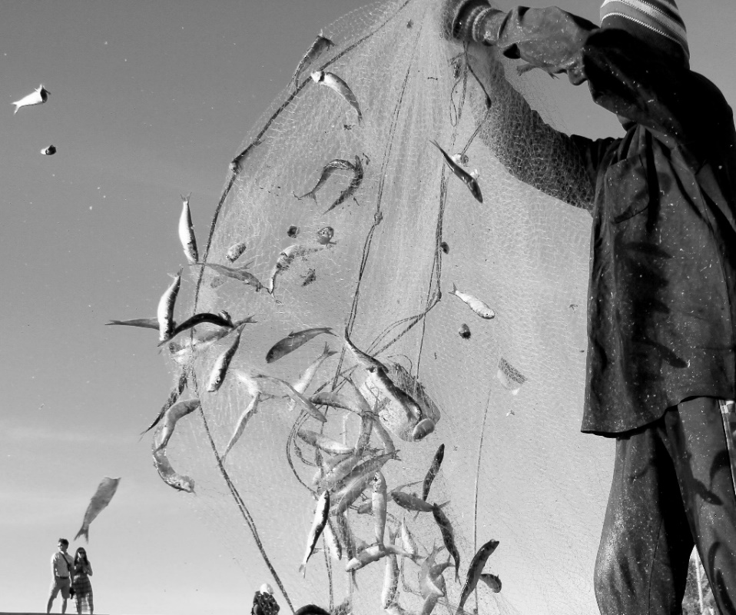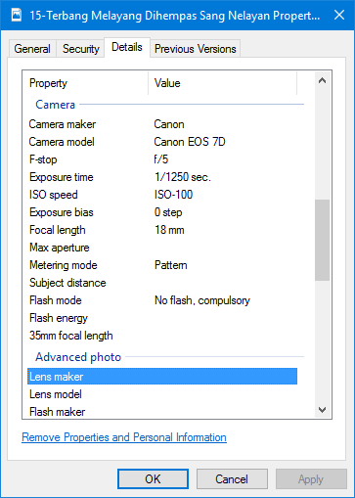

**Description:**

In this photo there is a fisherman swing his nets to collect the fishes. The fishes look like fly cause the swing from the fisherman. In high speed this moment is captured successfully.

|  |  |
| --- | --- |
| **Strength** | **Weakness** |
| Detail object in high speed movement | Low composition of color make this photo need to be monochrome |

**Photographic Technique:**

High Speed

**Editing Information:**

Crop, Color Level RGB, Brightness +51, Contrast +24, B/W

**16th Photo**

**“The Hunter and Their Prey**”

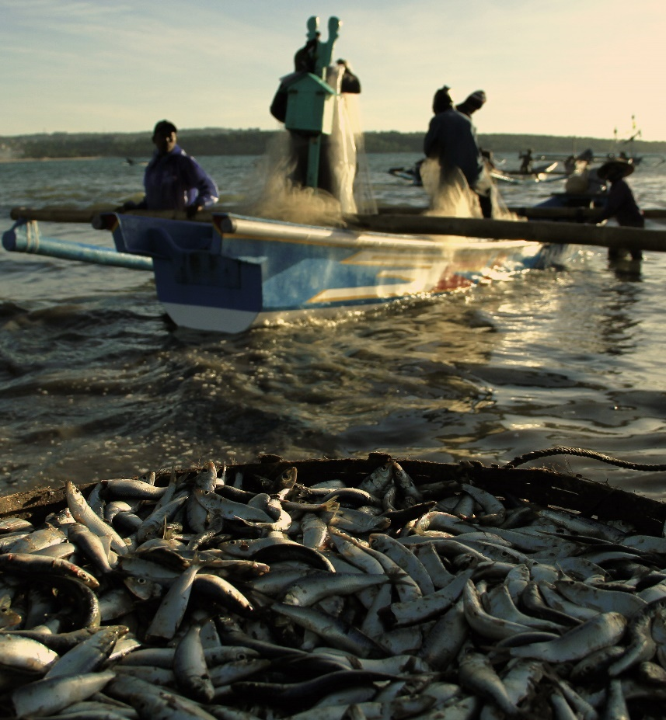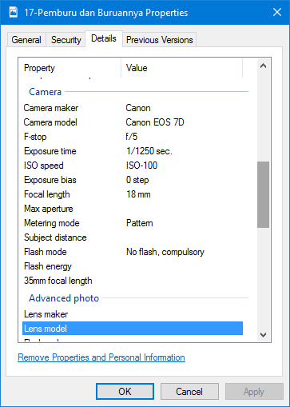

**Description:**

In this photo seen piles of fish that have been cleared by the fishermen. Visible contrast object captured in this photo where fishermen and hunters that prey is fish itself to be in a photo compositing.

|  |  |
| --- | --- |
| **Strength** | **Weakness** |
| Strong composition between object position and the background | Shadows of the object is not appears |

**Photographic Technique:**

High Speed

**Editing Information:**

Crop, Warning Filter, Density +47, Brightness +36, Contrast -32

**17th Photo**

**“Happiness in Simple Way”**

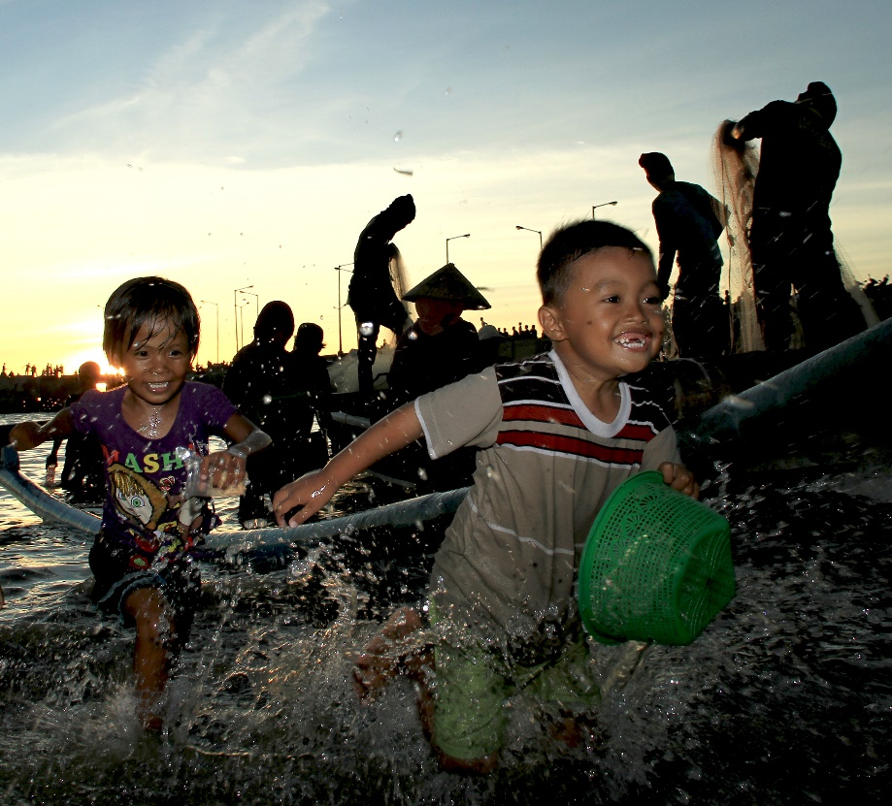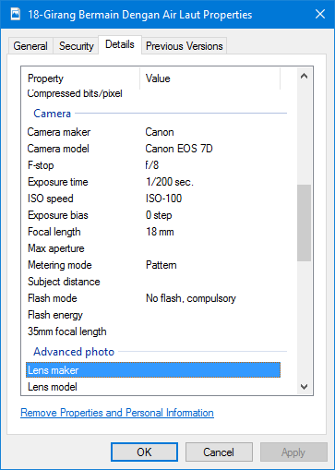

**Description:**

In this photo, seen two young children running in the sea water. Their smile proof of the happiness can be get in simple way. Playing with what you want and you can get the happiness. Splash of the water make the atmosphere on this photo is real and natural

|  |  |
| --- | --- |
| **Strength** | **Weakness** |
| Splash of the water make the atmosphere on this photo is real and natural | Limited sunlight when the dawn come |

**Photographic Technique:**

High Speed

**Editing Information:**

Crop, Exposure +0.44, Offset -0.0041, Gamma Correction +1.17, Brightness +2, Contrast +1

**18th Photo**

**“Killing the Time”**

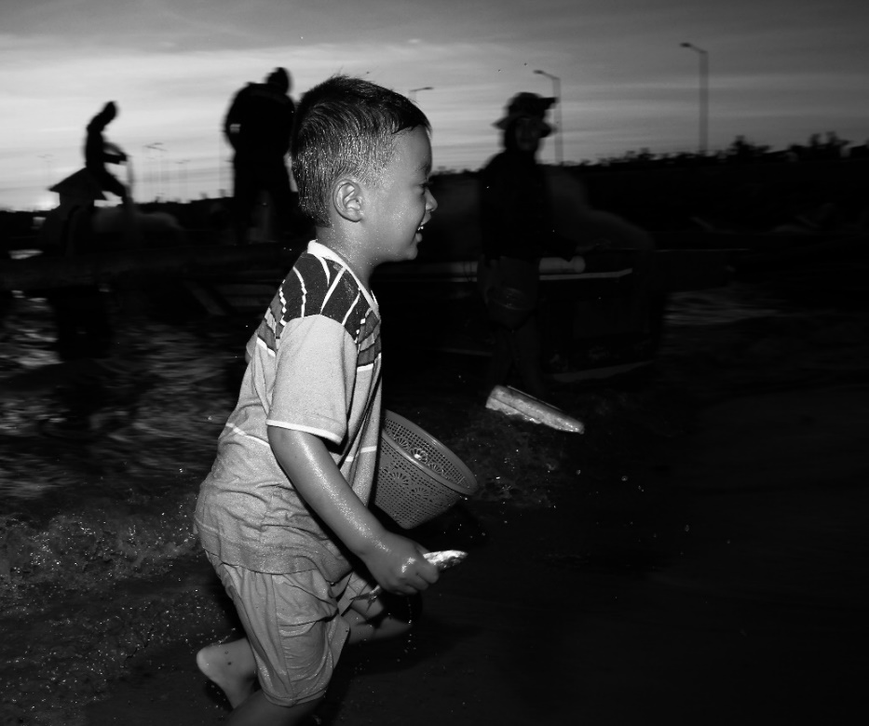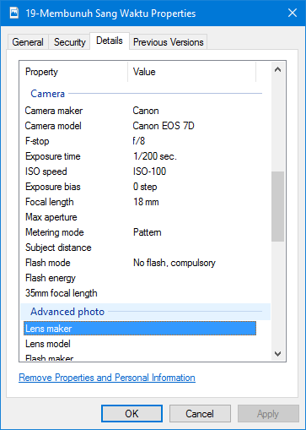

**Description:**

A boy from previous photo still running and plays with sea water near the fisherman activities.

|  |  |
| --- | --- |
| **Strength** | **Weakness** |
| Contrast between object and the background | Unperfected blur background and low combination of color |

**Photographic Technique:**

High Speed

**Editing Information:**

Crop, B/W, Brightness -21, Contrast +73

**19th Photo**

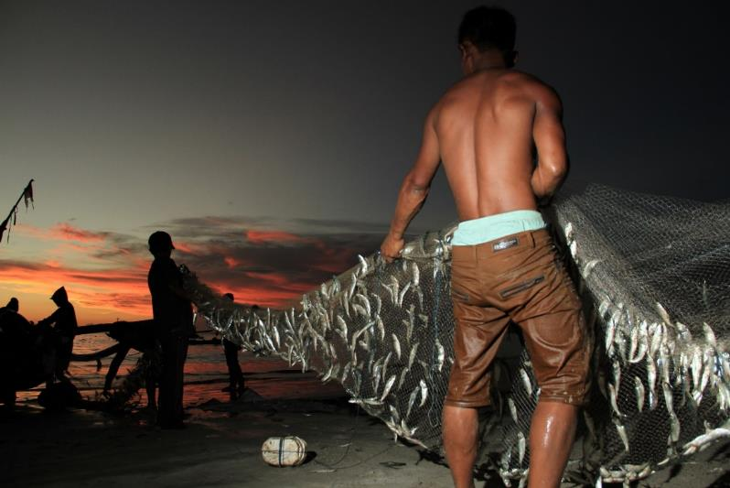**“My Body is A Proof of My Hard Work**”

**Description:**

The young fisherman with athletic body is a proof he is do his job seriously

|  |  |
| --- | --- |
| **Strength** | **Weakness** |
| Unique lighting between object without artificial lighting and with artificial lighting | Limited sunlight when the dawn come |

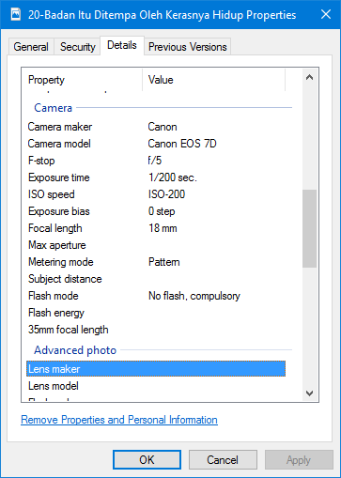

**Photographic Technique:**

Rules of Third

**Editing Information:**

None

**20th Photo**

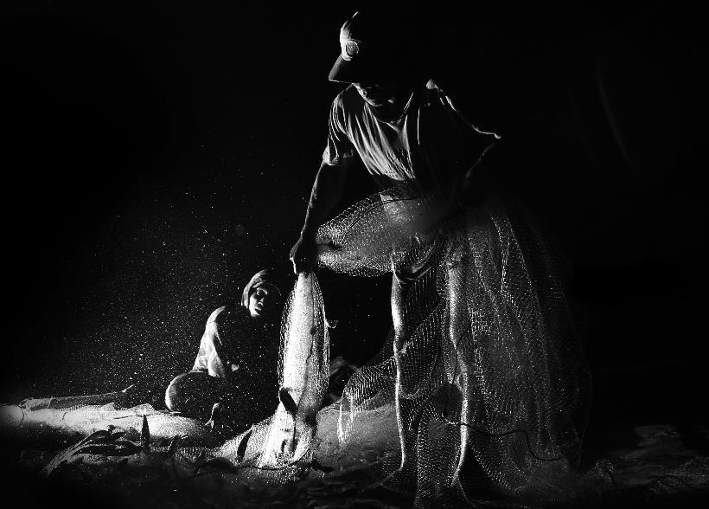**“No One Can Stop Us”**

**Description:**

Even the night has come, the fisherman still continue their work until complete

|  |  |
| --- | --- |
| **Strength** | **Weakness** |
| Unique lighting between object without artificial lighting and with artificial lighting | Limited sunlight when the dawn come |

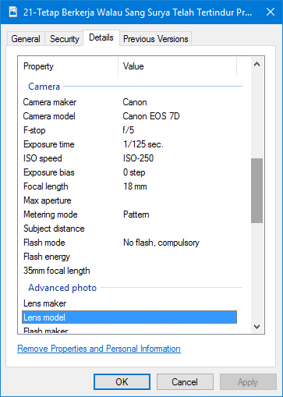

**Photographic Technique:**

Side Light

**Editing Information:**

Crop, B/W, Brightness +22, Contrast +33